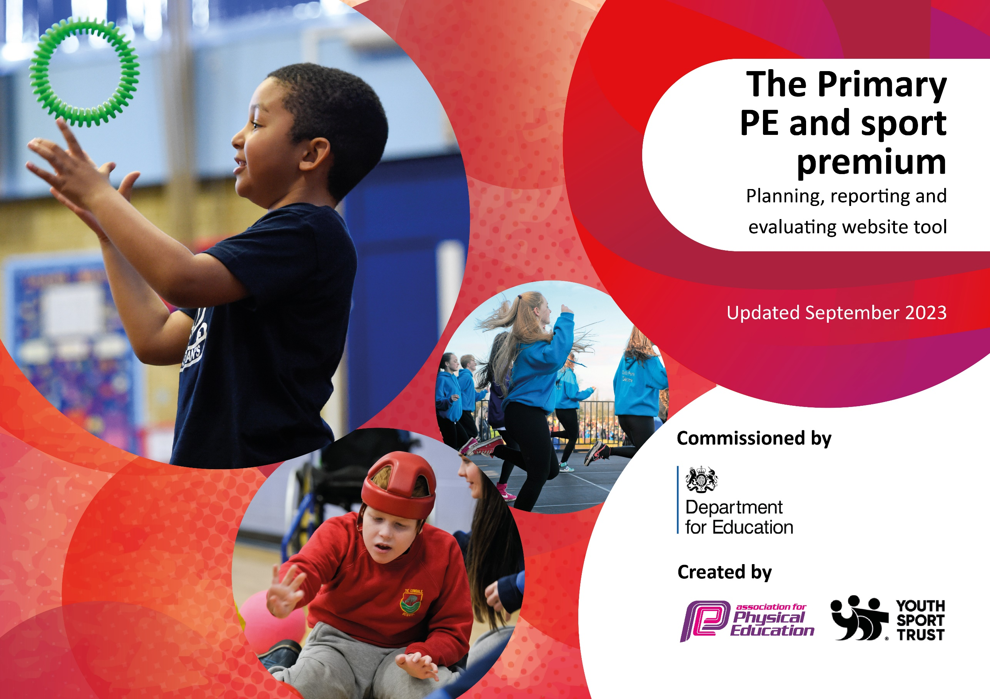

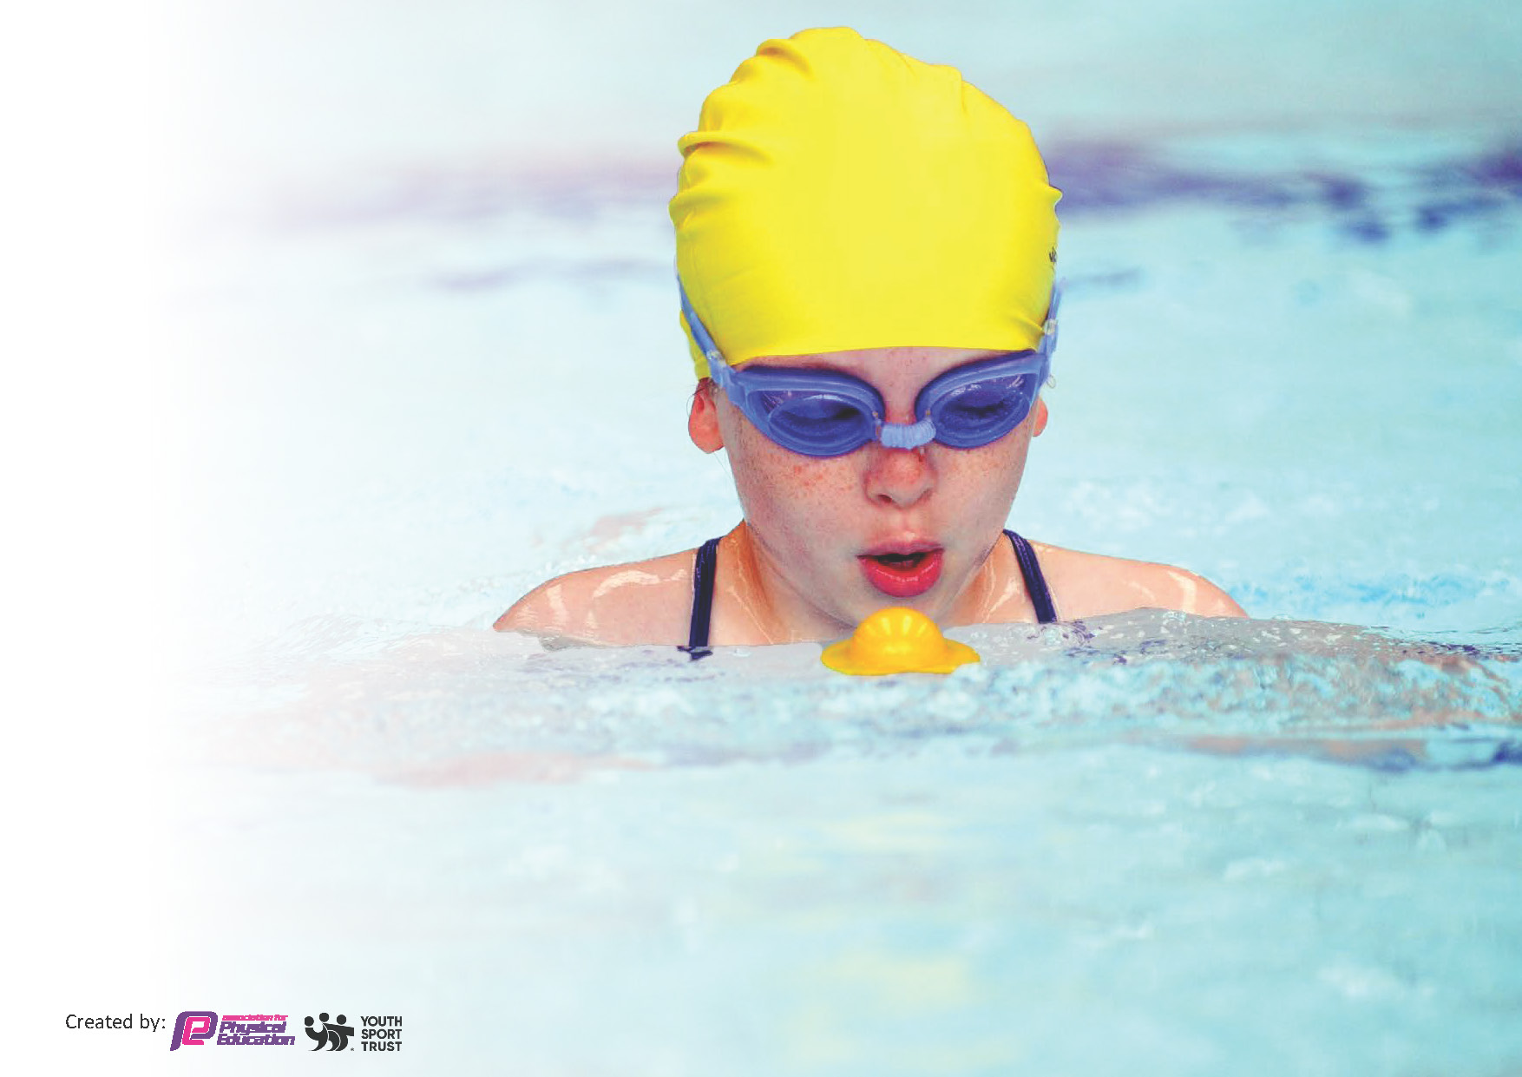
This template can be used for multiple purposes:
by:
- It enables schools to effectively plan their use of the Primary PE and sport premium
- It helps schools to meet the requirements (as set out in guidance) to publish information on their Primary PE and sport premium
- It will be an effective document to support Ofsted inspections enabling schools to evidence progress in Physical Education (PE) and evidence swimming attainment, which forms part of the PE National Curriculum. We would recommend schools consider
the Intent, Implementation and Impact of any spend, as examined within the Education Inspection Framework.

It is important that your grant is used effectively and based on school need.

Schools must use the funding to make additional and sustainable
improvements to the quality of the PE, School Sport and Physical Activity (PESSPA)
they offer. This means that you should use the Primary PE and sport premium to:

- Build capacity and capability within the school to ensure that improvements made now will benefit pupils joining the school in future years
- Develop or add to the PESSPA activities that your school already offers.

The Primary PE and sport premium should not be used to fund capital spend projects; the school’s core budget should fund these. Further detail on capital expenditure can be found in the updated Primary PE and sport premium guidance.

The Primary PE and sport premium guidance, outlines 5 key priorities that funding should be used towards. It is not

necessary that spending has to meet all the key priorities, you should select the priorities that you aim to use any funding towards.

Although completing this template is not a requirement for schools, schools are required to publish details of how they spend this funding. Schools must also outline what the impact this funding has had on pupils’ PE and sport participation and attainment and how any spending will be sustainable in the future. All funding must be spent by 31st July 2024.

The Department for Education has worked closely with the Association for Physical Education (afPE) and the Youth Sport Trust (YST) to develop this template and encourages schools to use it. This template is an effective way of meeting the reporting requirements of the Primary PE and sport premium.
Review of last year’s spend and key achievements (2022/2023)

We recommend you start by reflecting on the impact of current provision and reviewing your previous spend.

Activity/Action | Impact | Comments
The continuation of our weekly swimming lessons and gymnastics sessions across the school by trained professionals (excluding compulsory Year 3 sessions)  £1794.56 | All children receive 5 gymnastics sessions at a national gymnasium from professional gymnastic coaches each year, building upon each year’s progress and skills to ensure key teaching of core stability, balance and coordination, which is then building upon their knowledge of agility, balance and coordination taught in their Real PE sessions. All pupils in KS2 receive at least 5 sessions per year. To ensure key swimming skills and water safety is embedded within the children of Whitchurch Primary as a life skill. | Use of additional funding to cover extra Year 5 and 6 swimming sessions to improve results following COVID  Rent a pool scheme?
Funding went towards the continuation of ‘Week of Adventure’ where pupils of Whitchurch Primary experience a different sport/physical activity each day of the week. This year’s week consisted of: rock climbing, cricket, yoga and accumulated in a whole school trip to the Ninja Warrior assault course. Following this an inflatable assault course was covered by funding on the final day of school to link with their trip to Ninja Warrior assault course.  £1972.50 | 100% of children in school took part in our ‘Week of Adventure’ and experienced a new sport. ‘Week of Adventure’ encourages children to get outside and learn new sports following COVID. Children enjoyed climbing, cricket, yoga and a whole school visit to the ‘Ninja Warrior’ assault course, as seen on TV. Pupil voice states the huge enjoyment of new sports during the week and the enthusiasm to continue to lead a physical and healthy lifestyle following this experience. The assault course funded for the final day of school encouraged children to stay active over the summer holidays.
The continuation of Playpod Scrapstore on the playground  £1000 | Children can take part in physical building activities at break and lunch times through the continuation of the Playpod Scrapstore funding. This promotes physical activity, as well as improving social skills and problem solving to build using miscellaneous building equipment. | Potential stopping of Playpod and using funding for more tailored and long lasting equipment for children to enjoy.
4 Forest School sessions for each child from a Forest School trained staff member. Children learned about sustainability and survival skills, which also link to the curriculum (Eg Year 2 teach a geography topic through forest schools)  £2182 (Cost if LSA covered by school) | 100% of children took part in ‘Forest Schools’ and experienced outdoor skills and healthy living. Children took part in gardening sessions, extending their understanding of outdoor skills and healthy living. Following on from this, sports funding contributed towards our gardening club, in which children learnt about outside lifestyles and healthy living and cooking, and our ‘horticultural therapy sessions’ in which children receive emotional support through gardening. The children also build upon Geography objectives within outdoor learning. | We received a regional Gold standard award in recognition of this for the second year running.
Purchasing of sports equipment and supplies  £1660 | Sports equipment is up to date and mirrors all the equipment needed for all Real PE lessons and sports being taught across the curriculum. All PE session are fully equipped with the necessary and correct supplies to ensure teaching is of the highest quality. Orienteering equipment bought to complete Orienteering Week activities in a national effort to increase the teaching of OAA across primary schools. Football kits bought for school football team to promote and raise the profile of PE and sport across the school and to increase participation in competitive sport. A one off payment on staff PE kit for easy identification at sporting events and to raise the profile of PE across the school to improve whole school improvement.
Funding went towards Sports Coaching (We subsidise extra curricula PE so no child pays more than £3 per session. Also, coaches ran free lunchtime clubs each Wednesday and Friday) Sports Mentor (Worked 1:1 with children combining sports, Maths and well-being over 40 sessions)  £5400 | By subsidising extracurricular PE, no child pays more than £3 per session, which increased uptake in physical activity outside of the 2 hours per week and in turn promoting children to live and follow and healthy and active lifestyle. Sports Coaches also ran free lunchtime clubs every Tuesday, Thursday and Friday to all pupils to support their development in physical activities, as well as ensuring an increased participation in competitive sports within healthy competition amongst peers. Children also benefitted from the funding of a sports mentor, who worked 1:1 with children combing sports, mathematics and well-being over 40 sessions)
Real PE subscription renewed for the year.  £375 | Children are taught high-quality PE session through the use of the Real PE program. Children’s improvement in their Fundamental Movement Skills are highly evident in our baseline assessments completed in September of each year. Real PE also promotes physical education for all. Through the different levels of skills, the pupil of Whitchurch Primary are supported to develop as a whole child (socially/physically/creatively/cognitively/personally) at the skills level they are assessed and able to achieve.
To support the physical activities during break and lunch times, funding covered the cost of school playground markings.  £2695 | Children of Whitchurch Primary have the opportunity to participate in structured physical activities using the playground markings to promote healthy movement, engagement in regular physical activity and offering a broader range of physical movement outside of sport.

Key priorities and Planning
This planning template will allow schools to accurately plan their spending.

Action – what are you planning to do | Who does this action impact? | Key indicator to meet | Impacts and how sustainability will be achieved? | Cost linked to the action
Introduce consistent OAA sessions for all students (EYFS – Year 6)  £1500 | Teaching staff - as they need to lead the activity  Pupils – as they will take part  School Site Manager – as they will be installing the course around the school’s grounds | Key indicator 2 -The engagement of all pupils in regular physical activity – the Chief Medical Officer guidelines recommend that all children and young people aged 5 to 18 engage in at least 60 minutes of physical activity per day, of which 30 minutes should be in school.  Key indicator 4: Broader experience of a range of sports and activities offered to all pupils.  Key Indicator 1: Increased confidence, knowledge, and skills of all staff in teaching PE and sport. | Each pupil to complete 6 sessions a year of OAA, as well as multiple cross-curricular OAA opportunities to be planned across the curriculum. Pupils to gather a range of skills and experience OAA consistently, rather than just during Orienteering Week as previously sustained. | £1300 + travel costs for Cross-Curricular orienteering program (both online platform and permanent physical resources to be installed on school grounds.

‘Week of Adventure’ to be continued  £2000 | Subject lead – to organise and arrange all activities  Teaching staff - as they need to support the activity  Pupils – as they will take part. | Key indicator 2 -The engagement of all pupils in regular physical activity – the Chief Medical Officer guidelines recommend that all children and young people aged 5 to 18 engage in at least 60 minutes of physical activity per day, of which 30 minutes should be in school.  Key indicator 4: Broader experience of a range of sports and activities offered to all pupils.  Key indicator 3: Raising the profile of PE and sport across the school, to support whole school improvement | Pupils to continue to experience a range of new and existing sports through our ‘Week of Adventure’ to raise the profile of PE and healthy physical activities following COVID and to promote lifelong participation in sports and being physically active. | Around £2000 budget for the week of activities
Sports Coaching (We subsidise extra curricula PE so no child pays more than £3 per session. Also, coaches ran free lunchtime clubs each Wednesday and Friday) Sports Mentor (Worked 1:1 with children combining sports, Maths and well-being over 40 sessions)  £5400 | Sports coaches – running the extra clubs  Sports mentor – running the mentoring session  Pupils – who will partake | Key indicator 2 -The engagement of all pupils in regular physical activity – the Chief Medical Officer guidelines recommend that all children and young people aged 5 to 18 engage in at least 60 minutes of physical activity per day, of which 30 minutes should be in school.  Key indicator 3: Raising the profile of PE and sport across the school, to support whole school improvement  Key indicator 5: to promote increase participation in competitive sport | Children will be able to have access to a range of sports (both competitively and non-competitively) at lunchtimes, as well as more access to clubs and additional physical activities | £5400 (based on last year)
Real PE subscription renewed for the year.  £375 | Staff – using platform  Pupils – benefiting from the platform | Key Indicator 1: Increased confidence, knowledge, and skills of all staff in teaching PE and sport.  Key indicator 2 -The engagement of all pupils in regular physical activity – the Chief Medical Officer guidelines recommend that all children and young people aged 5 to 18 engage in at least 60 minutes of physical activity per day, of which 30 minutes should be in school.  Key indicator 4: Broader experience of a range of sports and activities offered to all pupils. | Children will continue to be taught high-quality fundamental movement skills and continue to show progress against September Baseline Assessments. | £375 for renewal
The continuation of our weekly swimming lessons and gymnastics sessions across the school by trained professionals (excluding compulsory Year 3 sessions)  £1794.56 | Children – who will receiving lessons  Staff – taking the children  Professionals at each establishment – leading the class and assessment | Key indicator 3: Raising the profile of PE and sport across the school, to support whole school improvement  Key Indicator 1: Increased confidence, knowledge, and skills of all staff in teaching PE and sport.  Key indicator 2 -The engagement of all pupils in regular physical activity – the Chief Medical Officer guidelines recommend that all children and young people aged 5 to 18 engage in at least 60 minutes of physical activity per day, of which 30 minutes should be in school.  Key indicator 4: Broader experience of a range of sports and activities offered to all pupils. | Children will continue to receive a well-rounded diet of swimming and gymnastics at WPS | £1794.56
4 Forest School sessions for each child from a Forest School trained staff member. Children learned about sustainability and survival skills, which also link to the curriculum (Eg Year 2 teach a geography topic through forest schools)  £1300 (Cost if LSA covered by school) | Children – who will receiving lessons  Staff – taking the children | Key indicator 3: Raising the profile of PE and sport across the school, to support whole school improvement  Key indicator 2 -The engagement of all pupils in regular physical activity – the Chief Medical Officer guidelines recommend that all children and young people aged 5 to 18 engage in at least 60 minutes of physical activity per day, of which 30 minutes should be in school.  Key indicator 4: Broader experience of a range of sports and activities offered to all pupils. | Children will continue to receive a well-rounded diet of outdoor learning and forest school | £1300

Key achievements 2023-2024
This template will be completed at the end of the academic year and will showcase the key achievements schools have made with their Primary PE and sport premium spending.

Activity/Action | Impact | Comments

Swimming Data
Meeting National Curriculum requirements for swimming and water safety.
Priority should always be given to ensuring that pupils can perform safe self-rescue even if they do not fully meet the first two requirements of the National Curriculum programme of study

Question | Stats: | Further context  Relative to local challenges
What percentage of your current Year 6 cohort can swim competently, confidently and proficiently over a distance of at least 25 metres? | 31% | Following COVID (Year 6 children had missed one-two years of swimming, including the 12 sessions in Year 3) we concentrated on life saving skills and water safety, as well as allocating additional sessions to this class.
What percentage of your current Year 6 cohort can use a range of strokes effectively [for example, front crawl, backstroke, and breaststroke]? | 29% | Following COVID (Year 6 children had missed one-two years of swimming, including the 12 sessions in Year 3) we concentrated on life saving skills and water safety, as well as allocating additional sessions to this class

What percentage of your current Year 6 cohort are able to perform safe self-rescue in different water-based situations? | 31% | Following COVID (Year 6 children had missed one-two years of swimming, including the 12 sessions in Year 3) we concentrated on life saving skills and water safety, as well as allocating additional sessions to this class
If your schools swimming data is below national expectation, you can choose to use the Primary PE and sport premium to provide additional top-up sessions for those pupils that did not meet National Curriculum  requirements after the completion of core lessons. Have you done this? | Yes | £754.06 of our Sports Premium funding has been spent on additional lessons for Year 4, 5 and 6 pupils to ensure there is progress in swimming ability following the disruption of swimming during COVID.
Have you provided CPD to improve the knowledge and confidence of staff to be able to teach swimming and water safety? | No | This will be a potential target for this year.

Signed off by:

Head Teacher: | Carl Hornsby
Subject Leader or the individual responsible for the Primary PE and sport premium: | Abigail Fudge
Governor: | Christine Dyer
Date: | 30/09/23

