Universal provision is based on inclusive approaches to teaching and learning which benefit all children but are essential for those with SEND. Reasonable adjustments for individual needs are made to ensure schools and settings are, for example, dyslexia-friendly, communication-supportive and adaptive for any sensory and physical needs that pupils may have.
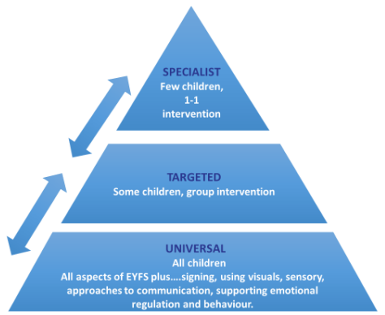
High Quality Teaching
- Scaffolds are used within learning until pupils are able to learn without them (stem sentences, vocabulary displayed)
- Movement breaks used where appropriate
- Consideration has been given to the seating arrangements within the classroom to take pupil needs into account
- Phonics interventions from Unlocking Letters and Sounds
Physical Adaptations
- Phonic/ sound or word mats
- Headphones / individually visually separate work space available for those that need it
- Wobble cushions
- Pencil grips, writing slopes
- Fidget toys
- Access to weighted blanket/ other weighted resource for those that need them
- Uncluttered and organised learning environments (Sept 2023)
- Visual timetables
- Now and Next boards
Pastoral
- Morning check ins from members of staff
- Morning regulating activities if required
- Access to Lunch Bunch (if hall is too noisy)
- Access to lunch time clubs (Sunshine Club, Yoga Club, Lego Club)

Universal Provision at Whitchurch Primary School

